Exporting Individual Students‘ grades and progress:

- On the home page, click into the learners tab located on the right.
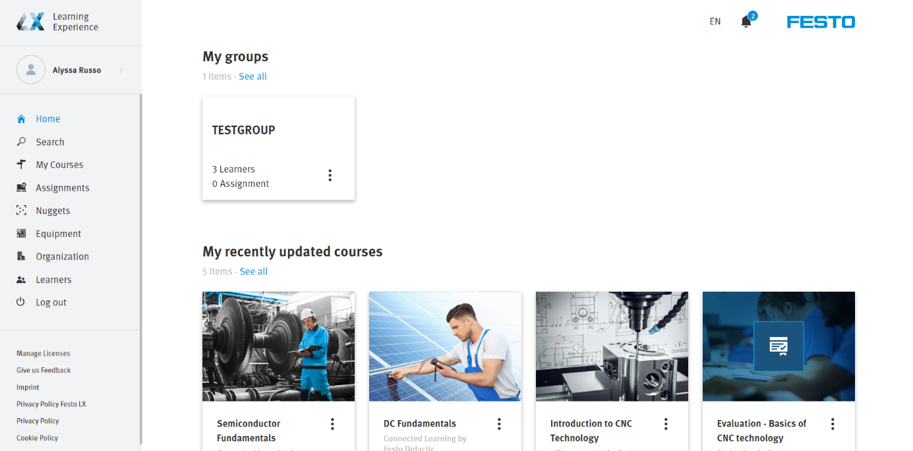
- Within the learners tab, click into the individuals section.
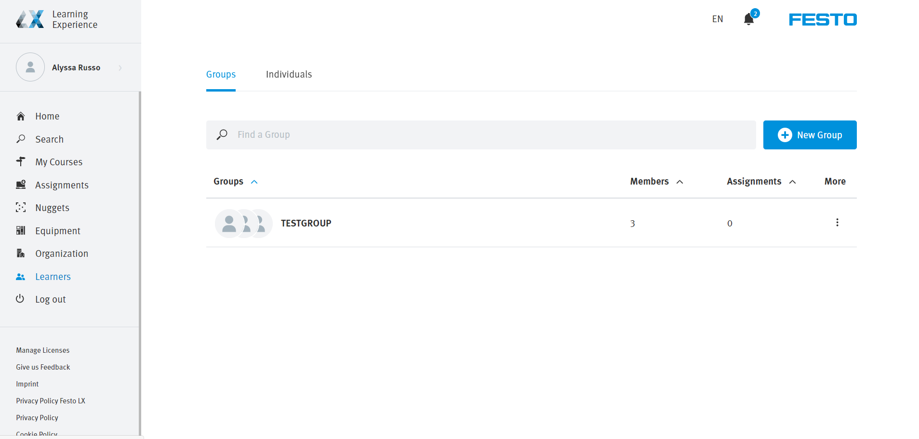

- On the right of each individual learner, there is three dots which will pull up a menu of options.
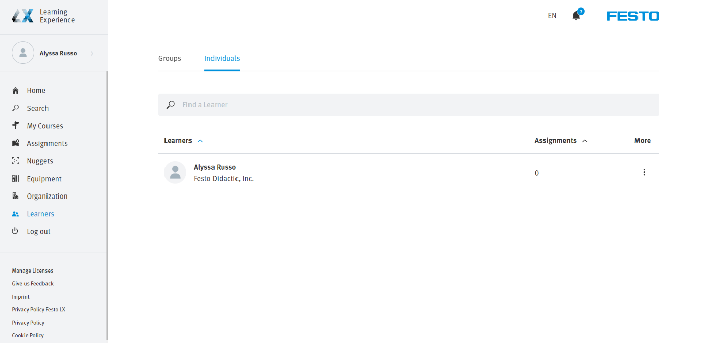
- Click on export results and an excel file will be generated with the courses the student is taking followed by their progress and success rates.
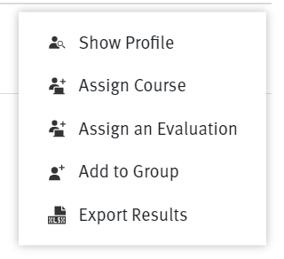

SAMPLE REPORT:
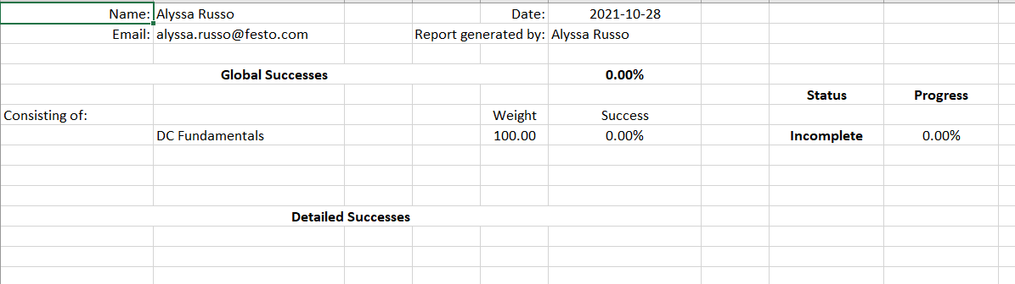

Export also can be done for the group:
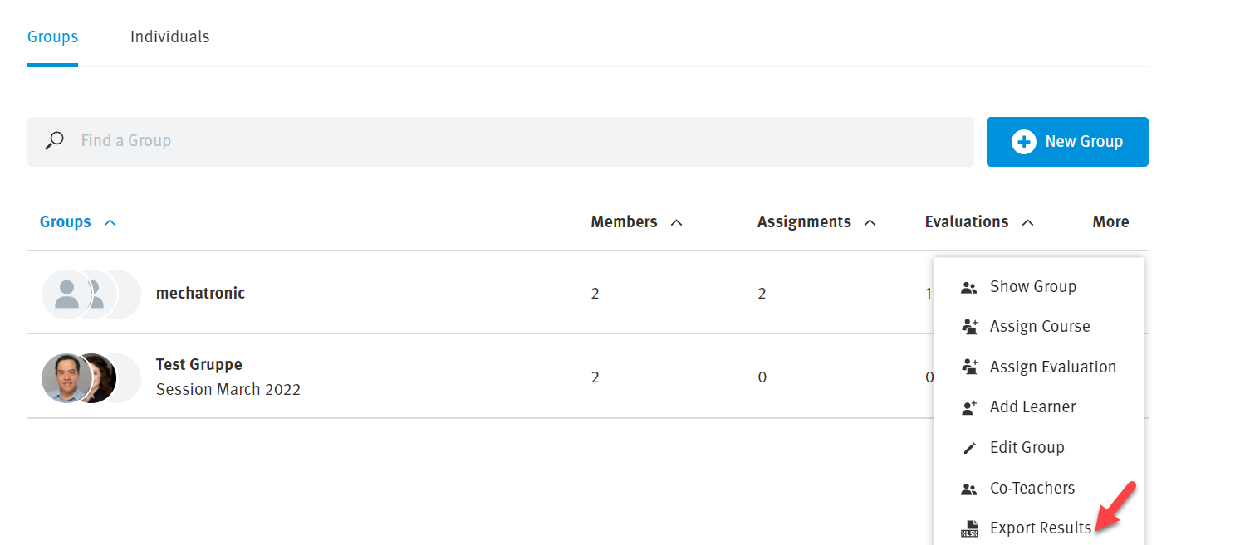

SAMPLE REPORT:

