Read Me First!

Thank you for your purchase of the SCADA LVDAC-EMS software. This software allows supervisory control and data acquisition (SCADA) over several LVDAC-EMS stations. Please, install and configure the SCADA LVDAC-EMS software as indicated in the present document before using it.

Installation and configuration of the SCADA LVDAC-EMS Software

Procedure
- Make sure that software LVDAC-EMS (version 3.18 or later) is installed on each computer that you plan to use as an LVDAC-EMS station.
- Install the SCADA LVDAC-EMS software on each computer that you plan to use as a SCADA LVDAC-EMS station.
- Connect the SCADA LVDAC-EMS software license key into a USB port of one of the computers used as a SCADA LVDAC-EMS station.
- To allow each SCADA LVDAC-EMS station to communicate with the different LVDAC-EMS stations via the local area network (LAN), it is necessary to import the OPC-server certificate file from each computer used as an LVDAC-EMS station. To do so, perform the three steps below.
  - On each computer used as an LVDAC-EMS station, locate the OPC-server certificate file (filename.cer) and copy it to a USB key. By default, the OPC-server certificate file is located in folder C:\Program Files (x86)\Festo Didactic\LVDAC-EMS\SCADA\Opc Server\Certificates.
  - Once the USB key contains the OPC-server certificate files of all computers used as LVDAC-EMS stations, copy all these files to folder C:\Program Files (x86)\Festo Didactic\Scada LVDAC-EMS\Opc Server\Certificates in each computer used as a SCADA LVDAC-EMS station.
  - On each computer used as a SCADA LVDAC-EMS station, import the certificates in the Certificate Store by running file ScadaImportCertificate.bat located in folder C:\Program Files (x86)\Festo Didactic\Scada LVDAC-EMS.
Tips for using the SCADA LVDAC-EMS software

Tip 1
To allow control and supervision of an LVDAC-EMS station through the SCADA LVDAC-EMS software, the LVDAC-EMS station must be set for SCADA operation. This is done by selecting the SCADA option in software LVDAC-EMS running at the LVDAC-EMS station, as shown in the figure below.
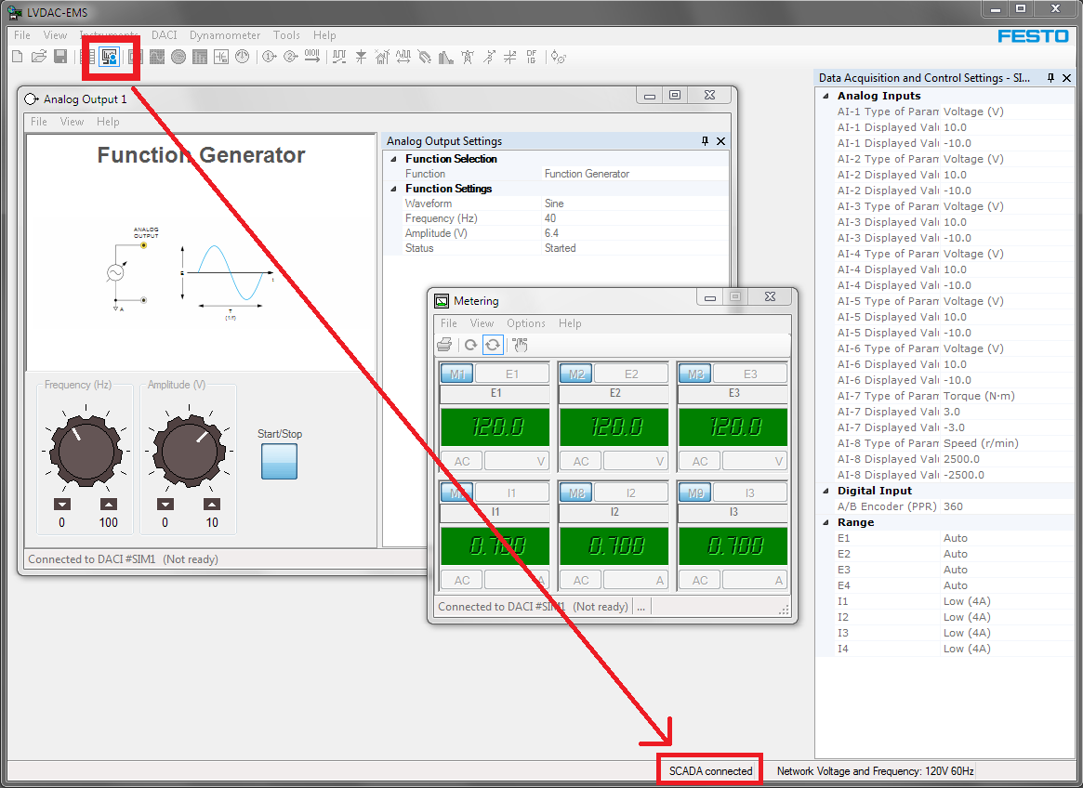

Tip 2
Identifying computers used as LVDAC-EMS stations is a common action performed when using the SCADA LVDAC-EMS software. The name of each of these computers is used in the SCADA LVDAC-EMS software as a means of identification.
To find the name of a computer running under Microsoft Windows 7, please refer to the figure below.
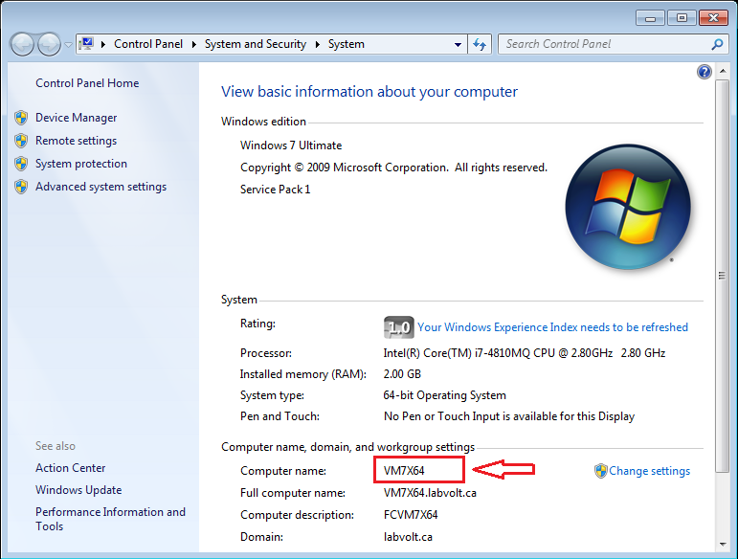
To find the name of a computer running under Microsoft Windows 10, please refer to the figure below.
